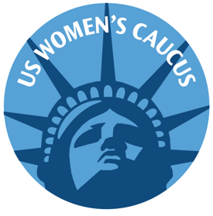

US WOMEN'S CAUCUS

*Feminist Advocacy at the UN*

December 13, 2023

The US Women’s Caucus is appalled by the recent ruling of the Supreme Court of the second largest state in our nation and the outrageous actions of its Attorney General regarding Kate Cox and her request for a life-saving abortion.

Think of it. An American woman with a very serious medical condition, an unviable pregnancy, had to flee her home state in order to get the life-saving medical attention she needed. Like a criminal, she was forced to escape the clutches of the Texas government, not because she was unable to find or afford good medical care but rather because she, her doctor, and even her husband were threatened with prosecution by the State for publicly asking for that life-saving procedure.

Limited government? The same politicians who decried too much government interference in personal lives, who objected to states telling them to wear a mask, who shouted about human rights abuses in China when they were forcing women to have abortions, now heartily endorse the idea that faceless, male-dominated state legislatures can pass laws that force American women to continue pregnancies, even at the risk to their health, their fertility, or even their own life.

Exceptions Are Meaningless. Even though the new Texas anti-abortion law allows exceptions to save the mother, both the Texas Attorney General and Supreme Court judges, all non-physicians, decided that Cox was not yet close enough to death’s door to deserve treatment, despite expert medical opinion. According to the Texas Supreme Court statement, “These laws reflect the policy choice that the Legislature has made, and the courts must respect that choice.” Clearly respect for exceptions, medical opinions, or the individual’s own choice did not count. The State rules. Period.

Land of the Free? This is the sorry place that the Dobbs decision has led America to today and the situation is only getting worse for women. With strident voices calling for a national abortion ban, there may soon be no place to flee to.

The Cox case should be a clarion call to arms for women. The message is clear. It is time to demand that the Equal Rights Amendment, already ratified by the required 38 states, be published in the US Constitution. Women can no longer depend upon their own state government, state officials, or the US Supreme Court to defend their choices, to protect their most basic rights, or even to get life-saving medical care when they need it.

The US Women’s Caucus urges all women to contact their Congressional representatives to demand action on the ERA, and to contact their state legislators to insist that women’s reproductive rights be respected, not abridged.

***US feminists collaborating to advance human rights and gender equity for women and girls worldwide***

***www.uswomenscaucus.org info@uswomenscaucus.org***